Introduction to Digital Logic

EECS/CSE 31L

**Assignment 1: 4-Input Multiplexer**

Prepared by: Jack Melcher

Student ID: 67574625

EECS Department

Henry Samueli School of Engineering

University of California, Irvine

January 14, 2015

**1 Block Description**

This block is designed to take in 2 inputs in order to select between another 4 inputs

**2 Input/Output Port Description**

|  |  |  |  |
| --- | --- | --- | --- |
| Port name | Port size | Port Type | Description |
| Input0 | 1 | IN | Value of first input |
| Input1 | 1 | IN | Value of second input |
| Input2 | 1 | IN | Value of third input |
| Input3 | 1 | IN | Value of fourth input |
| Select0 | 1 | IN | Gets the first select operand |
| Select1 | 1 | IN | Gets the second select operand |
| output | 1 | OUT | The operation result |

**3 Design Schematics**

**Truth Table:**

|  |  |  |
| --- | --- | --- |
| Sel_1 | Sel_0 | F |
| 0 | 0 | In_0 |
| 0 | 1 | In_1 |
| 1 | 0 | In_2 |
| 1 | 1 | In_3 |

**Boolean Expression:**

F = (Sel_1’)(Sel_0’)(In_0) + (Sel_1’)(Sel_0)(In_1) + (Sel_1)(Sel_0’)(In_2) + (Sel_1)(Sel_0)(In_3)

**Gate Representation:**



**4 Compilation**

4 to 1 mux code compiled

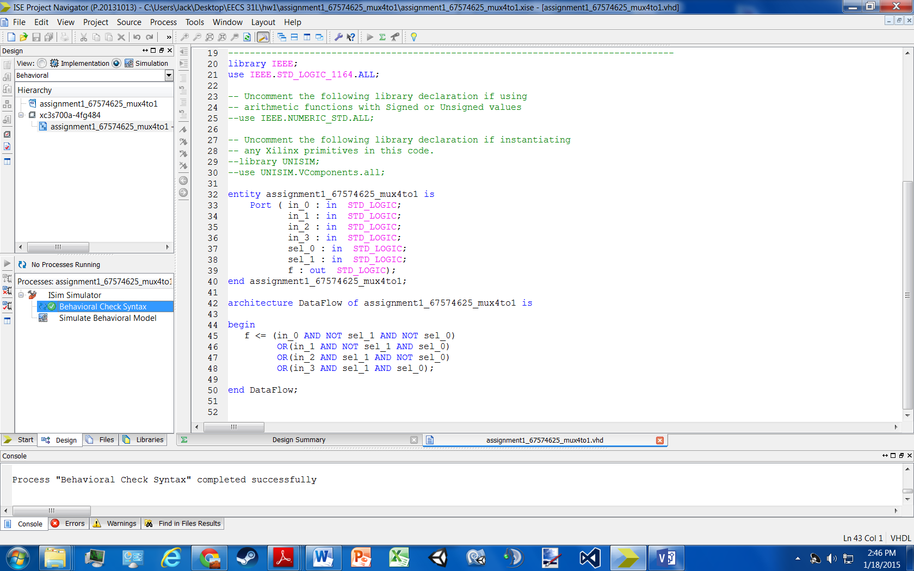

Testbench compiled

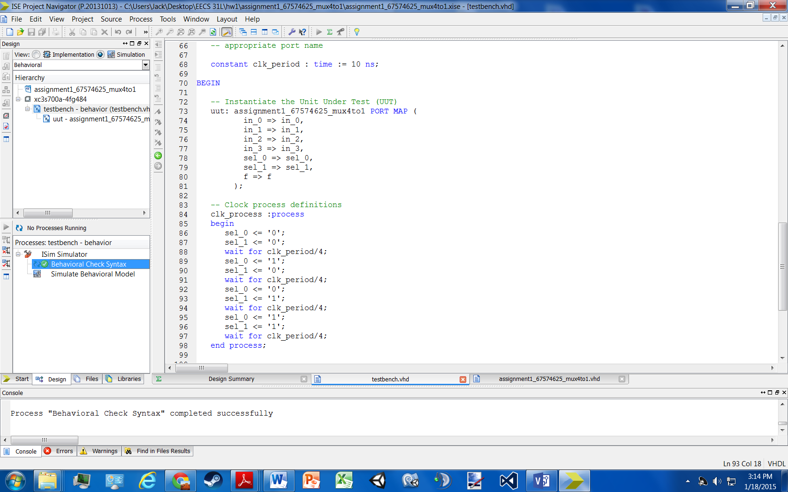

**5 Elaboration**

**Assumptions:**

* in_0, in_1, in_2, in_3 are only 1-bit
* f becomes ‘0’ when either in_0 or in_2 are selected because in_0 and in_2 = ‘0’
* f becomes ‘1’ when either in_1 or in_3 are selected because in_1 and in_3 = ‘1’
* Truth table above shows selection method.

**Errors:**

* No errors occurred while coding

**Simulation Log:**

Started : "Simulate Behavioral Model".

Determining files marked for global include in the design...

Running fuse...

Command Line: fuse -intstyle ise -incremental -o {C:/Users/Jack/Desktop/EECS 31L/hw1/assignment1_67574625_mux4to1/testbench_isim_beh.exe} -prj {C:/Users/Jack/Desktop/EECS 31L/hw1/assignment1_67574625_mux4to1/testbench_beh.prj} work.testbench {}

Running: C:\Xilinx\14.7\ISE_DS\ISE\bin\nt64\unwrapped\fuse.exe -intstyle ise -incremental -o C:/Users/Jack/Desktop/EECS 31L/hw1/assignment1_67574625_mux4to1/testbench_isim_beh.exe -prj C:/Users/Jack/Desktop/EECS 31L/hw1/assignment1_67574625_mux4to1/testbench_beh.prj work.testbench

ISim P.20131013 (signature 0x7708f090)

Number of CPUs detected in this system: 4

Turning on mult-threading, number of parallel sub-compilation jobs: 8

Determining compilation order of HDL files

Parsing VHDL file "C:/Users/Jack/Desktop/EECS 31L/hw1/assignment1_67574625_mux4to1/assignment1_67574625_mux4to1.vhd" into library work

Parsing VHDL file "C:/Users/Jack/Desktop/EECS 31L/hw1/assignment1_67574625_mux4to1/testbench.vhd" into library work

Starting static elaboration

Completed static elaboration

Compiling package standard

Compiling package std_logic_1164

Compiling architecture dataflow of entity assignment1_67574625_mux4to1 [assignment1_67574625_mux4to1_def...]

Compiling architecture behavior of entity testbench

Time Resolution for simulation is 1ps.

Waiting for 1 sub-compilation(s) to finish...

Compiled 5 VHDL Units

Built simulation executable C:/Users/Jack/Desktop/EECS 31L/hw1/assignment1_67574625_mux4to1/testbench_isim_beh.exe

Fuse Memory Usage: 29848 KB

Fuse CPU Usage: 420 ms

Launching ISim simulation engine GUI...

"C:/Users/Jack/Desktop/EECS 31L/hw1/assignment1_67574625_mux4to1/testbench_isim_beh.exe" -intstyle ise -gui -tclbatch isim.cmd -wdb "C:/Users/Jack/Desktop/EECS 31L/hw1/assignment1_67574625_mux4to1/testbench_isim_beh.wdb"

ISim simulation engine GUI launched successfully

Process "Simulate Behavioral Model" completed successfully

**6 Waveform**

Note: inputs and outputs are all 1-Bit

